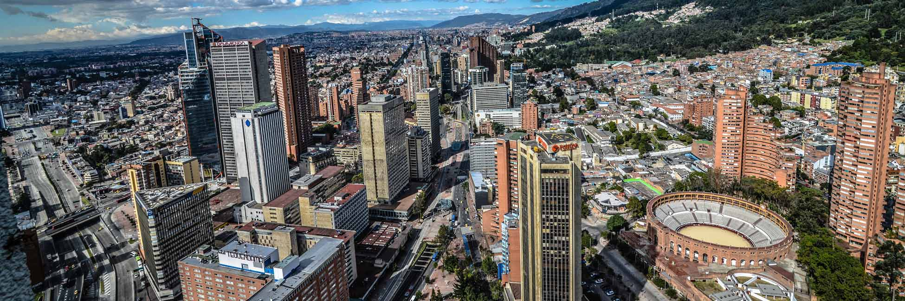

|  |
| --- |
| IBM Data Science Professional Certificate - Capstone |
| Vegan Market in Colombia |
| A Comparison between Bogotá and Medellin. |

|  |
| --- |
| Adriana Cortés Buelvas  June 26, 2020 |

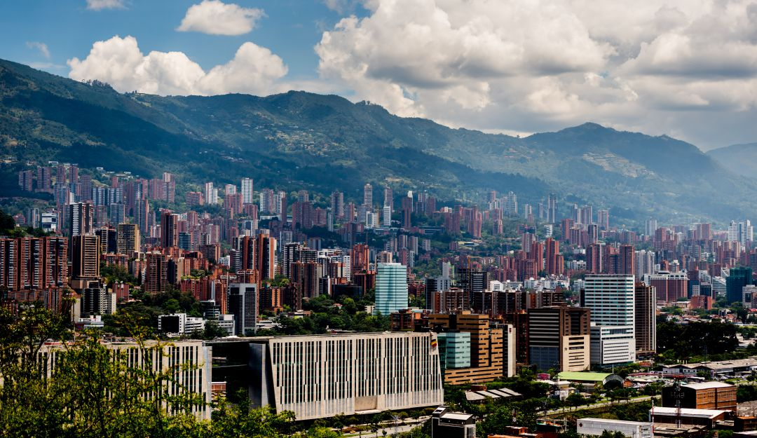

INDEX

Introduction ………………………………………………………………………………… 3

Data …………………………………………………………………………………………. 3

INTRODUCTION

Vegan Markets are places where people can acquire products that they would use in a daily basis but that are completely free from animal origin. As there is an increasing tendency toward a more sustainable life, people in many countries are changing the way they live, and with that, the way they eat. This is popular in big cities around the United States and in European Countries but in Latin America, is something that is still learning to walk. In this part of the world, young generations are being pioneers. Either as customers or as entrepreneurs in the Vegan Market world.

This Data Science Project aims two types of population that can be interested on it. The first one are investors or stakeholders that would like to support Vegan Markets in Colombia and would like to know if it would be better to start in Bogotá –the country’s capital; or in Medellin – Colombia’s, second largest city. The second population that can be interested on it are vegan market entrepreneurs in one of these two cities. I hope the insights found here would help them to make decisions about where to begin their new business.

DATA

Foursquare and Google Maps APIs will power the location data. I aim to look for different venues in both of the cities, how are they distributed within the neighbourhoods and where are the existing Vegan Markets placed on each of the cities. What are some characteristics of the neighbourhoods surrounding these places and what can be attractive for new customers.

Jupyter Notebook associated to this project will display the Datasets.